**Three Stage Battery Charging**

A fully charged lead acid battery has a negative electrode made of lead, a positive electrode made of lead dioxide, and an electrolyte that is made of sulfuric acid and water. During the discharge cycle (when the battery is being used), the chemical composition of the battery changes until it becomes completely discharged.

A completely discharged battery is comprised of two electrodes that have been transformed into lead sulfate and an electrolyte that is almost 100 percent water.

To charge a discharged battery, a voltage greater than the battery voltage is applied to the battery terminals.

During the course of charge cycle, the chemical reaction that occurred during the discharge is being reversed. Charging and thus the chemical reaction continues until the battery becomes 100 percent charged.

The battery that is completely charged will once again have a negative electrode made of lead, a positive electrode made of lead dioxide, and an electrolyte that is made of sulfuric acid and water.

**Charge Cycle:**

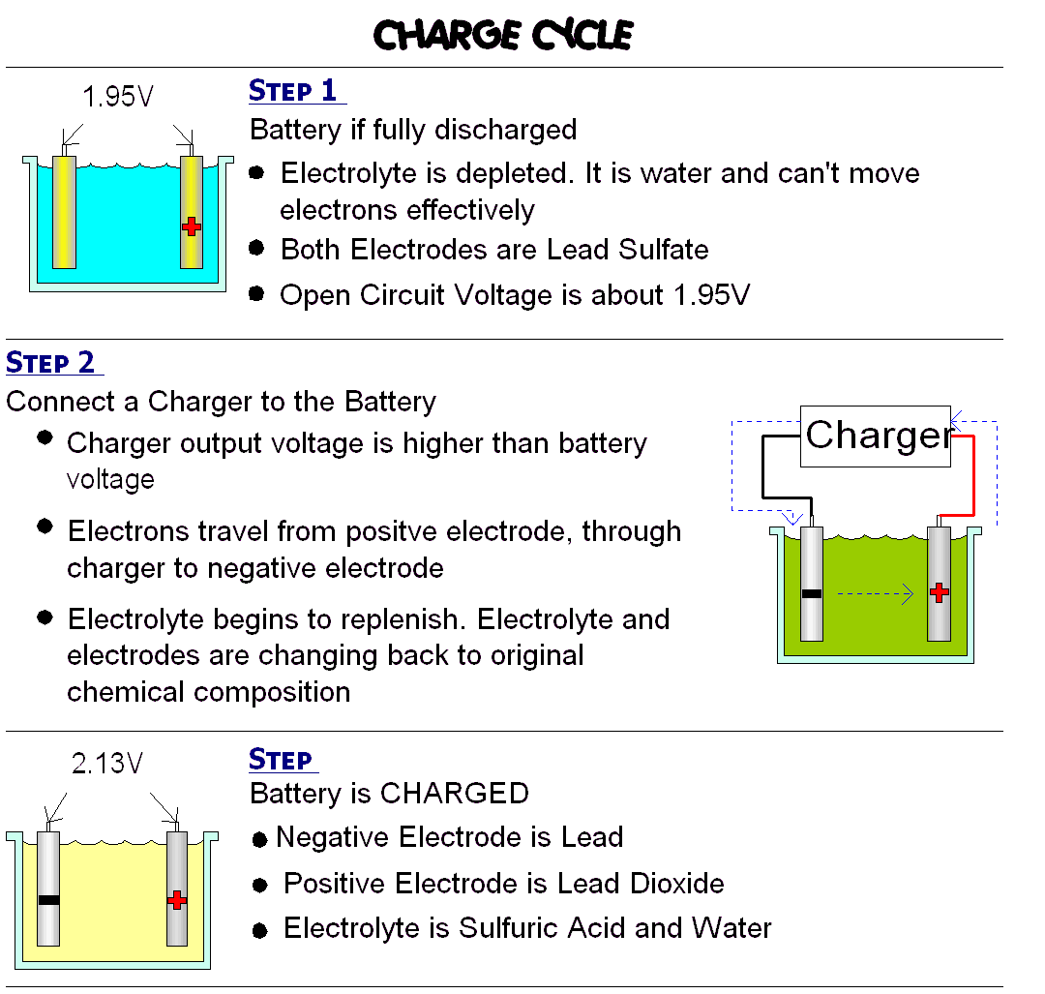

The internal resistance of a battery does become greater as a battery becomes discharged.  However, this type of increased resistance refers to an opposition to battery discharge current.

During the charge cycle however, it is important to consider another kind of internal resistance. Specifically the resistance to a charge current. This resistance increases as the battery becomes more charged.

As the battery becomes more charged, the voltage produced by the individual cells increases and opposes the charge current. This behavior is frequently referred to as “series opposing” and does represent a resistance to current flow coming from the battery charger.

Three stage battery chargers use this phenomenon to determine which stage of charging to be applied to a battery during the charge cycle.

These three stages of charging are known as **bulk**, **absorption** and **float** charging.

Bulk Charge:

This first stage is typically where the highest voltage and amperage the charger is rated for will actually be used. The level of charge that can be applied without overheating the battery is known as the battery's natural absorption rate. For a typical 12 volt AGM battery, the charging voltage going into a battery will reach 14.6-14.8 volts, while flooded batteries can be even higher. For the gel battery, the voltage should be no more than 14.2-14.3 volts. If the charger is a 10 amp charger, and if the battery resistance allows for it, the charger will put out a full 10 amps. This stage will recharge batteries that are severely drained. There is no risk of overcharging in this stage because the battery hasn't even reached full yet.

The type of charger selected will be driven by the capacity and type of battery being charged. For example, what is required for a Gel battery can differ significantly from an AGM battery.

In this stage, the battery charger will rapidly return the battery to an 80 to 90 percent state of charge.

It accomplishes this by maintaining a constant relatively high current. The current is held constant against the rising internal resistance to charge current by raising the battery voltage.

**Consider Ohms Law** where Voltage = I (current in Amps) x R (resistance in Ohms).

A quick survey of this equation shows that if we want to maintain a constant current in a circuit with rising resistance, we must raise the voltage.

The bulk charge continues until the voltage output by the charger reaches a specific level. At that point, it switches to the absorption charge.

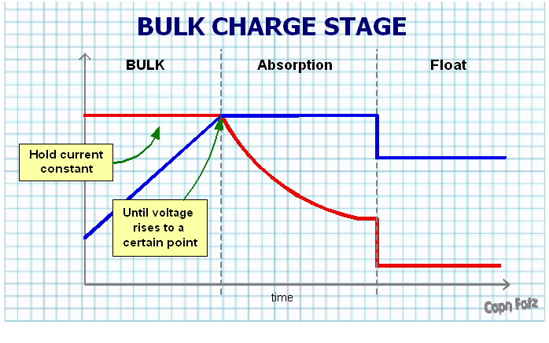

Absorption Charge:

At this point most chargers will maintain a steady voltage, while the amperage declines. The lower current going into the battery safely brings up the charge on the battery without overheating it.

This stage takes more time. For instance, the last remaining 20% of the battery takes much longer when compared to the first 20% during the bulk stage. The current continuously declines until the battery almost reaches full capacity.

In this stage, the voltage applied to the battery by the charger is held at a constant level. As the charger holds this level, it is also monitoring the current being supplied.

Remember as the battery becomes increasing charged, it’s opposition or resistance to a charge current increases. This will cause the current flow to tail off.

**Consider Ohms Law** once again where Voltage = I (current in amps) x R (resistance in ohms)

If voltage is held constant and resistance increases, current must decrease.

During the absorption charge, the three stage charger monitors the falling current until a specified point is reached that indicates that the battery is about ninety eight percent charged.

When this specified level of current is reached, the three stage battery charged will switch to the float charge stage.

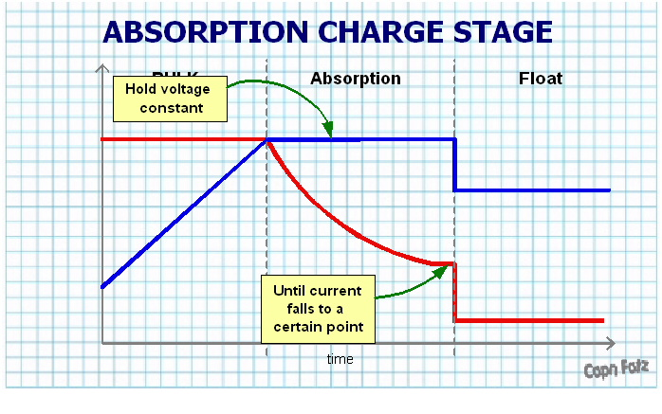

Float Charge:

Some chargers enter float mode as early as 85% state of charge but others begin closer to 95%. Either way, the float stage brings the battery all the way through and maintains the 100% state of charge. The voltage will taper down and maintain at a steady 13.2-13.4 volts, which is the [maximum voltage a 12 volt battery can hold](https://www.batterystuff.com/kb/frequently-asked-questions/powersports-batteries-faq/12-volt-battery-reading-13-volts.html). The current will also decrease to a point where it's considered a trickle. That's where the term "trickle charger" comes from. It's essentially the float stage where there is charge going into the battery at all times, but only at a safe rate to ensure a full state of charge and nothing more. Most smart chargers do not turn off at this point, yet it is completely safe to leave a battery in float mode for months to even years at a time.

All Lead acid [batteries](https://www.batterystuff.com/batteries/) (Gel, AGM, Flooded, Drycell, etc) are made up of a series of 2.2 volt cells that are bridged together in series to reach their final desired voltage. For instance, a 6 volt battery will have 3 cells (3 x2.2= 6.6 volts), a 12 volt battery will have 6 cells (6 x2.2=13.2 volts) and so on.That 2.2 volts is the fully charged, straight off the charger number. The actual resting voltage, or the voltage a battery will settle at 12-24 hours after being removed from the [charger](https://www.batterystuff.com/battery-chargers/), is closer to 2.1 volts per cell, or about 6.4 volts for a 6v battery, and 12.7 volts for a 12v battery. These numbers assume 100% healthy cells, and may vary a bit lower for older batteries.

During the float charge, the voltage is dropped to a level lower than what was applied during the absorption charge. The float charge serves two purposes…

* First, it brings the battery from a 98 percent state of charge to a 100 percent state of charge.
* Second, it maintains the battery in a 100 percent state of charge condition.

It is this second stage that deserves some discussion as there are a couple ways of maintaining the battery at 100 percent state of charge.

**The first** is to simple apply a voltage that is theoretically ideal to the type of battery being charged. The idea is that this voltage is low enough to keep the electrolyte from boiling off, yet high enough to counteract the phenomenon known as self discharge.The problem with this is that it does not account for the affect that temperature has on batteries, nor does it account for those small differences caused by battery age and construction.

**The second** is to actually monitor the state of charge and apply voltage when it’s needed. Indeed, some of the smarter chargers use temperature sensors. Others monitor the voltage of the cells and send a short pulse of charge using a technique called a pulse width modulation.

